Wa-Shokuiku – Learn. Cook. Eat Japanese! Recipes
Lesson 7: Obento

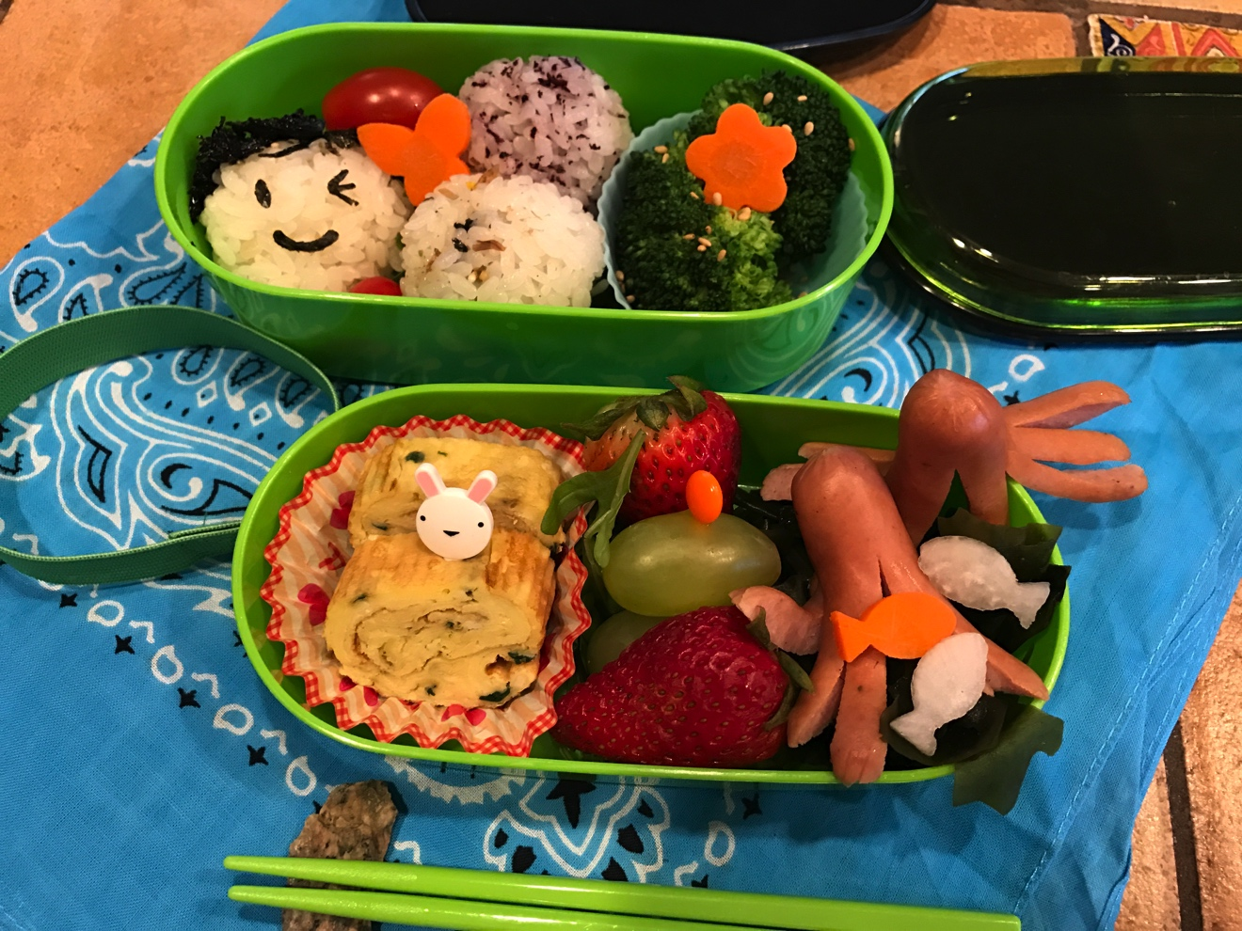
This class on bento was designed to have the children use all the skills and knowledge they have gained over the course of this class. The most important aspects of a bento lunch box is:
- Use 5 different colors through choosing a variety of healthy foods
- Use small portions
- Arrange the food attractively because you “eat with your eyes.”

Onigiri
(see Lesson 1 recipe)

Tamagoyaki

Traditionally a rectangular pan is used to make this omelet. This recipe is designed for using a round skillet.

Makes 1 roll - approximately 6 pieces

- 1 tablespoon canola oil plus more for additional rolls
- 2 eggs
- 2 tablespoons water
- 2 teaspoons sugar
- 1 teaspoon soy sauce
- 1-2 tablespoons chopped chives (or scallion tops) optional

- In a bowl, whisk together eggs, water, sugar, soy sauce and chives.
- In a small 6 or 8-inch skillet heat the pan on medium heat for 1 minute. Add the oil to the pan. Heat until the oil until it begins to shimmer. With a paper towel wipe the oil from the pan and set the paper towel into a ramekin.
- Pour the egg mixture all at once into pan. Let the mixture cook until just set – about 1-2 minutes.
- With a spatula fold the right side of the omelet into the center. Then fold the left side to meet the edges of the right side.
- With a spatula from the edge closest to you, begin to roll the omelet away from you until you form a log. Place the egg roll onto a piece of foil and wrap the around the egg log. Twist the ends closed and set aside until completely cool.
- When cool cut into 6 pieces.

Octopus Tako Weiner
These mini wieners are cut into the shape of an octopus. When the wieners are cut and placed in boiling water the legs curl up like an octopus. Instead of boiling you can also saute in a small amount of oil and then add a little ketchup and continue to stir fry until the legs curl.

- Mini hot dogs
- Ketchup for dipping – optional

- Cut the weiner, just below the tip (head) and to the bottom lengthwise. Make another lengthwise cut through the halves to make 4 legs. Carefully cut each leg in half lengthwise to make 8 legs. You can do 4 – it is fine.
- Have skillet or small saucepan filled half way with water. Bring the water to a boil. Add the hot dogs. Cook for 1 minute or until the legs curl. Remove with a slotted spoon.
- Set on a plate and return to students to place in their boxes. You can provide ketchup for dipping.

Broccoli or Asparagus with Lemon Soy Sauce
- 1 cup broccoli florets
- 1 tablespoon light soy sauce
- 2 teaspoons fresh lemon juice.

- Cut broccoli into individual spears.
- Bring a small sauce pan filled half way with water to a boil. Add the broccoli, lower the heat and cook for about 3 minutes until broccoli turns bright green but is cooked through. Drain and set aside.
- Mix the soy sauce and lemon juice.
- Place several broccoli florets into a small cupcake holder.
- Drizzle on Lemon soy sauce.

Carrot , cheese and or daikon flower/star garnishes
Japanese food is often decorated with edible garnishes that reflect the season.

- 1 2-inch wide large carrot
- Small daikon
- Four 1/2-inch thick cheese /ham slices - optional

- Cut carrots and daikon into 1/2 – inch slices and par boil the vegetables. This makes cutting shapes easier.
- With small cutting molds of stars or hearts or what every you have on hand cut shapes from the vegetables. Straws are good for cutting circles from vegetables.
- Cheese or ham slices are also good for cutting shops.
- Arrange around the bento box to add color.

